PLANT & SPECIALIST SOCIETIES
23 – 26 April 2026

Thank you for your interest in the forthcoming Harrogate Spring Flower Show, to be held at the Great Yorkshire Events Centre, Harrogate, between 23-26 April 2026. When completing an application, please note the following information:

APPLICATION PROCESS
- Completed application closing date is Friday 28 November 2025.
- Submitted applications must include a completed form, full payment, proof of Public Liability Insurance (£5m, valid between 23– 26 April 2026) and a show-related risk assessment.
- All electronic applications will receive a confirmation receipt email.
- All applicants will be notified of the success of their application by mid-December.

PAYMENTS & REFUNDS
- Full payment, where applicable, is required at the time of application and in any case, no later than the application closing date of Friday 28 November 2025.
- Refunds for unsuccessful applications will be made by BACS once allocation has been completed.

VENUE & SITE INFORMATION
- Space is offered as either table only or with display staging – please select your requirements from the options provided.
- One selling table is available for the sale of literature, society-specific products, plants, seeds and bulbs. Please note that it is encouraged that plant material to be sold should, wherever possible, be grown or produced by/for the society and/or its members. All plants to be sold must be potted individually.
- For those not wishing to sell, a maximum of two promotional tables are available free of charge.
- Four exhibitor badges and one parking pass are provided for the purposes of manning your stand. Limited additional badges (valid all four days of the show) can be purchased for £24.00 each by calling the show office on 01423 648212.

PRODUCT TO BE EXHIBITED
- Only products noted on the application form and approved can be sold during the show.

Please be aware that completion of this application does not represent a guarantee of space within the event. All allocation of stands is at the discretion of Harrogate Flower Shows.

For further T&Cs, visit https://www.flowershow.org.uk/exhibitors/info/rules-and-regulations

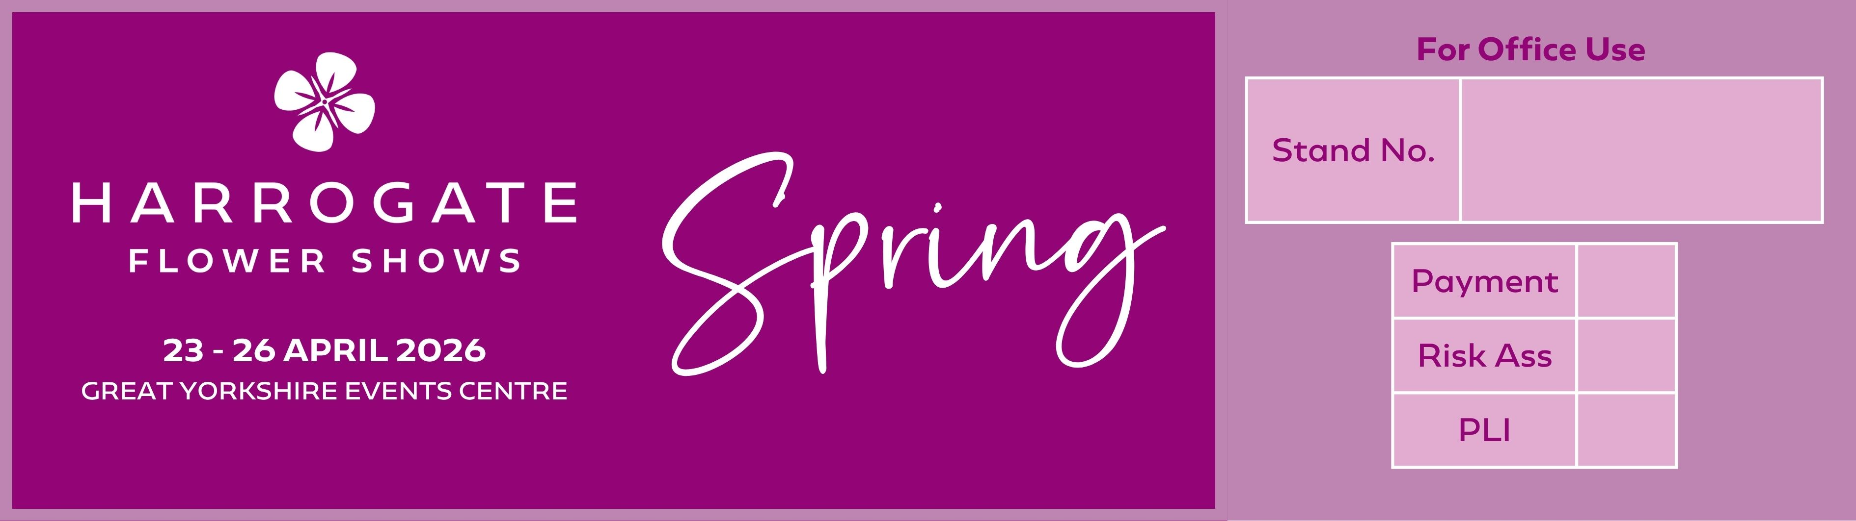

PLANT & SPECIALIST SOCIETIES APPLICATION

Contact name
Trading name
Address |  |  |  | Alternative details for listings
Telephone number |  |  |  | Mobile
Email address
Website
(for inclusion on our website)
Plant types to be displayed and judged
Please specify judging criteria (select one only) | Traditional |  | Educational/Scientific
 |  | Cost (ex VAT) |  |  |  | TOTAL (INC VAT)
1 x selling table (1.8m x 0.75m)* |  | £140.00
Total cost Inc. VAT
Do you require a promotional/demonstration area? If yes, please specify 1 or 2 tables.
(Table measurement - 1.8m x 0.75m)

Do you require staging? |  |  |  | YES
 |  |  |  | NO
If no, state space only size in metres.

Staging requirements (Please see attached staging sheet to select staging type, skip section if space only).
Option A - Island stands (answer 1 & 2)
- State height of island stand. |  |  | 30cm from floor
 |  |  | 60cm from floor
- State edging of island stand. |  |  | No edging |  |  | 10cm deep |  | 15cm deep
 | 3m | Circle
 | 3m | Square
Option B - Wall stands (answer 1, 2, 3 & 4)
- Select length of stand. |  |  |  |  | 3m
 |  |  |  |  | 4.5m
 |  |  |  |  | 6m
 |  |  |  |  | 7.5m
 |  |  |  |  | 9m
- Do you require a 2.4m high back rail? |  |  |  |  | Yes
 |  |  |  |  | No
- State staging type (must relate to staging offered). |  |  |  |  |  |  | (For example - B)
- Do you require edging? If no, leave blank. |  |  |  |  |  |  | Front only |  |  | Front & sides |  | All round
 |  |  |  |  | 10cm deep
 |  |  |  |  | 15cm deep
Do you have any other comments relating to your staging?

Any refunds will be made by BACS, please complete details below.
Bank name |  |  |  | Sort code
Name on account |  |  |  | Account code
Payment:
- Only completed application forms with full payment will be considered for space.
- All invoices will be e-mailed.
- We do not accept cheques

The following must be provided with your application:
- Proof of Public Liability Insurance £5,000,000 valid over event date
- Completed show related Risk Assessment

BACS  Please state trading name as BACS reference |  |  | Account name: Harrogate Flower Show Ltd  Account number: 02562332  Sort code: 53-50-21
Credit/debit card |  |  | Please telephone 01423 648211
Please use the box below for any comments.
Note:
- Please ensure that your completed application together with full payment and Public Liability Insurance (£5m), are received by Harrogate Flower Show no later than Friday 28 November 2025.
- All space and categorisation therein, is allocated at the discretion of the organiser.

Signed

Date

