PLANT NURSERY DISPLAY (INDOOR) & SALES
23-26 APRIL 2026

Thank you for your interest in the forthcoming Harrogate Spring Flower Show, to be held at the Great Yorkshire Events Centre, Harrogate, between 23-26 April 2026. When completing an application, please note the following information:

APPLICATION PROCESS
- Completed application closing date is Friday 28 November 2025.
- Submitted applications must include a completed form, full payment, proof of Public Liability Insurance (£5m, valid between 23– 26 April 2026) and a show-related risk assessment.
- All electronic applications will receive a confirmation receipt email.
- All applicants will be notified of the success of their application by mid-December.

PAYMENTS & REFUNDS
- Full payment is required at the time of application and in any case, no later than the application closing date of Friday 28 November 2025.
- Refunds for unsuccessful applications will be made by BACS once allocation has been completed.

VENUE & SITE INFORMATION
- Plant Nursery displays and associated sales are located in the Floral Pavilion within Hall 1.
- Displays, unless specified as space only, will be provided with pre-built staging, based on the completed application form. Plant storage facilities will be provided within a designated stock area.
- Please note that black staging cloth is NOT PROVIDED as part of your display and is the responsibility of exhibitors to organise in advance.
- For Plant Nursery displays, there is the option of a covered sales space on Main Avenue, offering 4m x 4m in a standalone structure with curtain fronts and sides, located on grass. Please bring appropriate equipment to prepare your stand for potential adverse weather conditions.
- For temporary electricity supply, a form will be issued to successful applicants.
- Two exhibitor badges and one parking pass are provided with your stand. Limited additional badges (valid all four days of the show) can be purchased for £24.00 each by calling the show office on 01423 648212.

PRODUCT TO BE EXHIBITED
- Only plants and associated product noted on the application form and approved can be sold.

Please be aware that completion of this application does not represent a guarantee of space within the event. All allocation of stands is at the discretion of Harrogate Flower Shows.

For further T&Cs, visit https://www.flowershow.org.uk/exhibitors/info/rules-and-regulations
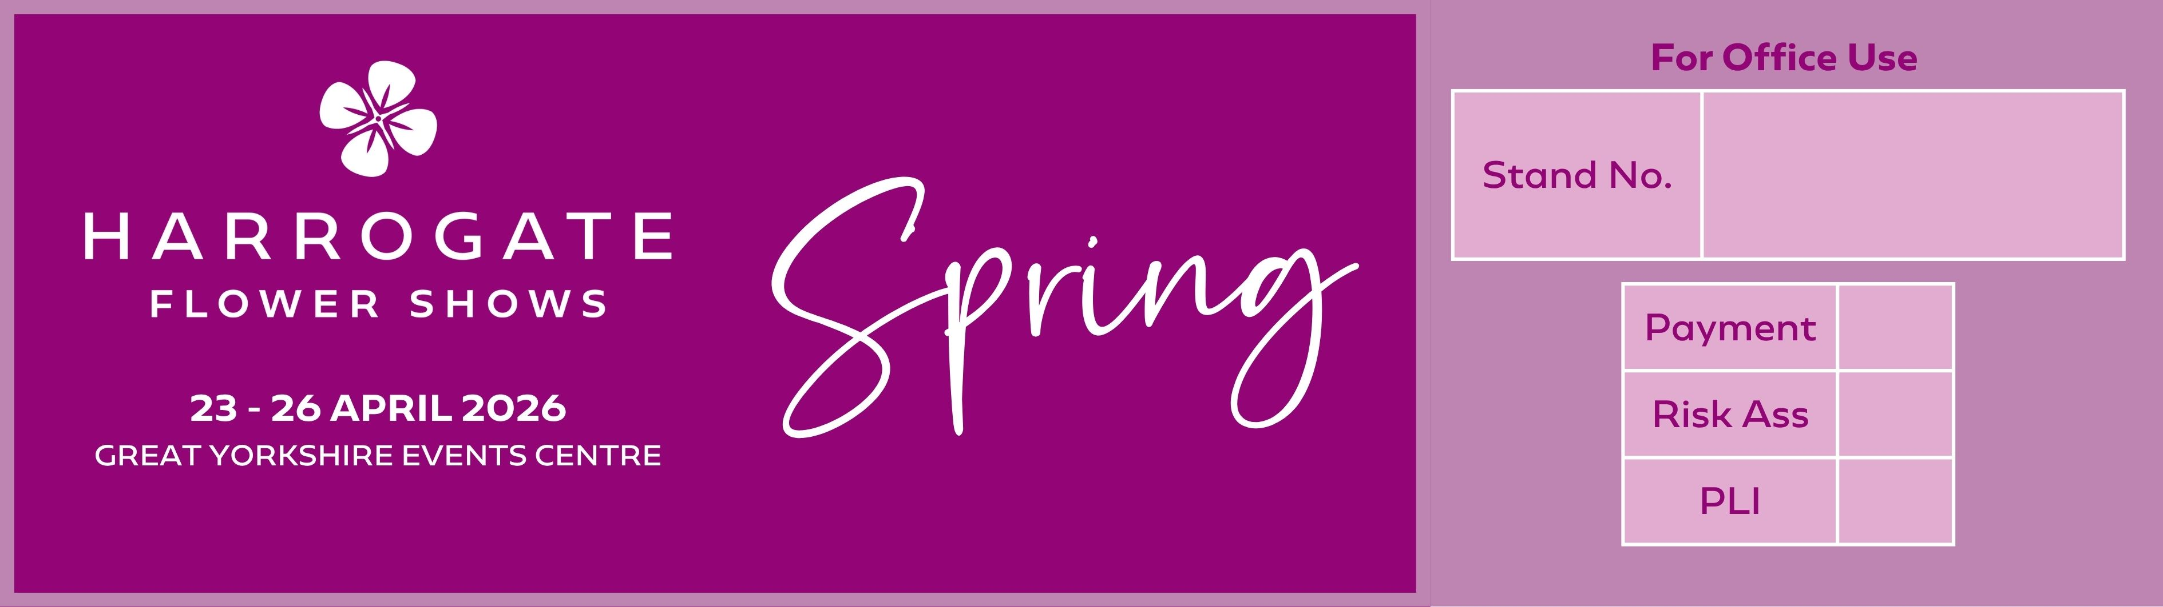
PLANT NURSERY DISPLAY (INDOOR) & SALES APPLICATION

Contact name
Trading name
Address |  |  | Alternative details for promotional use
Telephone number |  |  | Mobile
Email address
Website
(for inclusion on our website)
Plant types
(display & judging)
Please circle judging criteria | Traditional |  |  | Educational/Scientific
Plant types to be sold
SPACE
Colonnade on Main Avenue |  | Cost (ex VAT) |  |  |  | Quantity | Total (ex VAT)
Individual Pagoda sales structure (4m x 4m) |  | £690.00
Floral Pavilion (Hall 1) sales tables |  | Cost (ex VAT) |  |  |  |  | Total (ex VAT)
1 x selling table, 1.8m x 0.75m |  | £140.00
2 x selling tables, 3.6m x 0.75m |  | £270.00
3 x selling tables, 5.4m x 0.75m (Islands only) |  | £340.00
Total cost (ex VAT)
VAT @ 20%
TOTAL COST PAID (INC VAT)

Do you require staging? |  |  |  |  |  | YES
 |  |  |  |  |  | NO
If no, state space only size in metres.

Staging requirements (Please see attached staging sheet to select staging type, skip section if space only).
Please note that black staging & backdrop cloth is NOT PROVIDED and is the responsibility of the exhibitor
Option 1) - Island stands (answer 1 & 2)
- State height of island stand. |  |  |  |  | 30cm from floor
 |  |  |  |  | 60cm from floor
 |  |  |  |  | No edging |  |  | 10cm deep |  |  | 15cm deep
 | 3m | Circle
 | 3m | Square
 | 3.6m | Oval
 | 4.5m | Circle
 | 4.5m | Square
Option 2) Wall stands (answer 1, 2, 3 & 4)
- Select length of stand. |  |  |  |  |  |  | 3m
 |  |  |  |  |  |  | 4.5m
 |  |  |  |  |  |  | 6m
 |  |  |  |  |  |  | 7.5m
 |  |  |  |  |  |  | 9m
- Do you require a 2.4m high back rail? |  |  |  |  |  |  | Yes
 |  |  |  |  |  |  | No
- State staging type (must relate to staging offered). |  |  |  |  |  |  |  |  | (For example - B)
- Do you require edging? If no, leave blank. |  |  |  |  |  |  |  |  | Front only |  |  |  | Front & sides |  |  | All round
 |  |  |  |  |  |  | 10cm deep
 |  |  |  |  |  |  | 15cm deep
Do you have any other comments relating to your staging?

Any award monies or refunds will be made by BACS, please complete details below.
Bank name |  |  |  |  |  |  |  |  |  | Sort code
Name on account |  |  |  |  |  |  |  |  |  | Account code
Payment:

- Only completed application forms with full payment will be considered for space.
- All invoices will be e-mailed.
- We do not accept cheques.

The following must be provided with your application:

- Proof of Public Liability Insurance £5m valid over event date
- Completed show related Risk Assessment

BACS (preferred).  Please state trading name as BACS reference |  |  |  |  | Account name: Harrogate Flower Show Ltd  Account number: 02562332  Sort code: 53-50-21
Credit/debit card |  |  |  |  | Please telephone 01423 648211
Please use the box below for any comments.
Note:
- Please ensure that your completed application together with full payment and Public Liability Insurance £5m are received by Harrogate Flower Show no later than Friday 28 November 2025.
- All space and categorisation therein, is allocated at the discretion of the organiser.

Signed

Date

