

LIFESTYLE PAVILION
23 -26 April 2026

Thank you for your interest in the forthcoming Harrogate Spring Flower Show, to be held at the Great Yorkshire Events Centre, Harrogate, between 23-26 April 2026. When completing an application, please note the following information:

APPLICATION PROCESS
- Completed application closing date is Friday 28 November 2025.
- Submitted applications must include a completed form, full payment, proof of Public Liability Insurance (£5m, valid between 23– 26 April 2026) and a show-related risk assessment.
- All electronic applications will receive a confirmation receipt email.
- All applicants will be notified of the success of their application by mid-December.

PAYMENTS & REFUNDS
- Full payment is required at the time of application and in any case, no later than the application closing date of Friday 28 November 2025.
- Refunds for unsuccessful applications will be made by BACS once allocation has been completed.

VENUE & SITE INFORMATION
- The Lifestyle Pavilion is located within a solid-floored temporary marquee at the venue, with spaces 2m deep and a minimum 3m frontage. Additional frontage can be purchased by the metre.
- All stands are space only, with no shell scheme provided. Each stand is based against either a marquee/internal wall and any structure/divider and hanging is the responsibility of the exhibitor.
- For temporary electricity supply, a form will be issued to successful applicants.
- Two exhibitor badges and one parking pass are provided with your stand. Limited additional badges (valid all four days of the show) can be purchased for £24.00 each by calling the show office on 01423 648212.

PRODUCT TO BE EXHIBITED
- Only products noted on the application form and approved can be sold during the show.

Please be aware that completion of this application does not represent a guarantee of space within the event. All allocation of stands is at the discretion of Harrogate Flower Shows.

For further T&Cs, visit https://www.flowershow.org.uk/exhibitors/info/rules-and-regulations

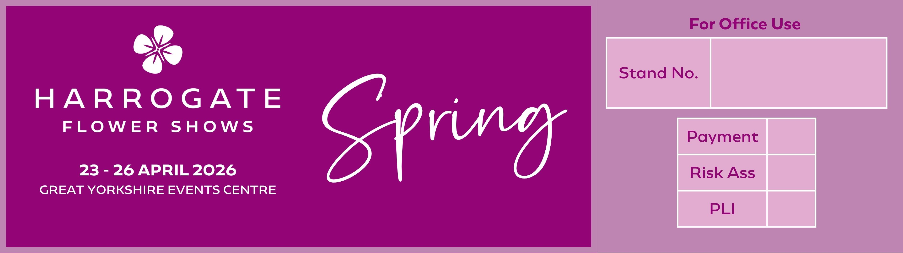

LIFESTYLE PAVILION APPLICATION

Contact name
Trading name
Address |  |  |  | Alternative details for promotional use
Telephone number |  |  |  | Mob:
Email address
Website
(for inclusion on our website)
Products to be exhibited
SPACE |  | Cost  (ex VAT) | Space required  (inc add. frontage) |  |  | Total  (ex VAT)
Space within marquee (3m x 2m) |  | £490.00
- Additional frontage per metre |  | £163.00
- Double aspect (2 sides open – limited avail) |  | £110.00
Total cost (ex VAT) |  |  |  |  |  | £
VAT @ 20% |  |  |  |  |  | £
TOTAL COST PAID (inc VAT) |  |  |  |  |  | £

Any refunds will be made by BACS, please complete details below.
Bank name |  |  |  | Sort code
Name on account |  |  |  | Account code
Payment:
- Only completed application forms with full payment will be considered for space.
- All invoices will be e-mailed.
- We do not accept cheques

The following must be provided with your application:
- Proof of Public Liability Insurance £5,000,000 valid over event date
- Completed show related Risk Assessment

BACS  Please state trading name as BACS reference |  |  | Account name: Harrogate Flower Show Ltd  Account number: 02562332  Sort code: 53-50-21
Credit/debit card |  |  | Please telephone 01423 648211
Please use the box below for any comments.
Note:
- Please ensure that your completed application together with full payment, Public Liability Insurance (£5m) and risk assessment is received by Harrogate Flower Show no later than Friday 28 November 2025
- All space and categorisation therein, is allocated at the discretion of the organiser.

Signed

Date

