

Creative Borders 2026

Call for Entries
Harrogate Flower Shows is once again delighted to announce the return of the Creative Borders category at the 2026 Spring Show, set to be held between 23-26 April at the Great Yorkshire Showground, Harrogate.
Offering a unique platform to share creativity and garden inspiration, the competition supports designers, plantspeople and contractors from throughout the north of England in raising awareness of their work to tens of thousands of visitors across the four-day event.
All successful applicants will receive:
• A grant of £200 to support cost of project materials.
• The opportunity to engage with potential clients from over 40,000 visitors across the show.
• The chance to win the ‘Top Border’ award, with prize money of £500

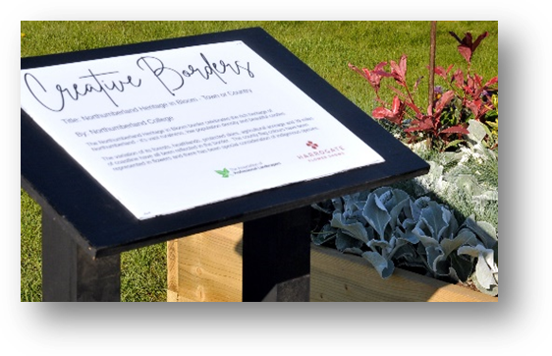
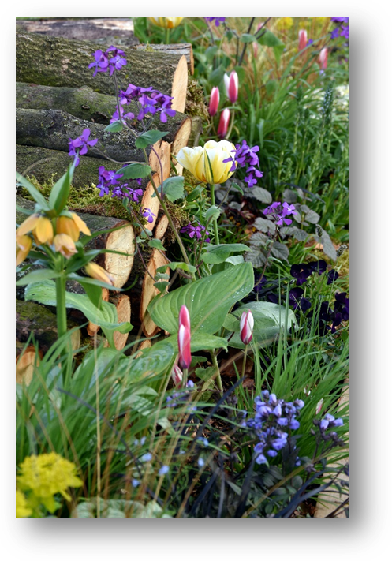

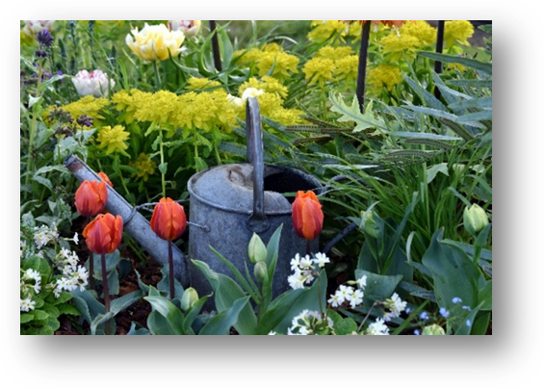

The Brief
With over a century’s heritage in promoting practical gardening, 2026’s Harrogate Spring Flower Show sees the return of its most achievable and wide-ranging competition yet – and for those taking part, it couldn’t be easier!

Whether it promotes the work you do, or explores the boundaries of creative design, we want to encourage involvement from designers, groups and organisations across the horticultural sector. This is the ideal opportunity to let your imagination run riot as you design and plant your perfect scheme.

Each successful applicant will have a dedicated plot, consisting of a pre-made raised timber bed, 3.6m long and 1.2m wide, with a height of approximately 60cm. Beds will be filled with topsoil, ready for you to create your unique celebration of planting.

You are free to use whichever props and additions you may need to complete your masterpiece. A display board will be provided adjacent to your plot, offering an opportunity to promote your work.

All entrants have two days to complete their project, with judging taking place on Wednesday 22 April.

How to enter
If you would like any further information or help on submitting an application, contact the show team on info@flowershow.org.uk
Please complete the application with as much detail as possible as it will not only form the basis of your promotion, but also assist the judges in the award process.
Applications should be returned to application@flowershow.org.uk by 24 October 2025.
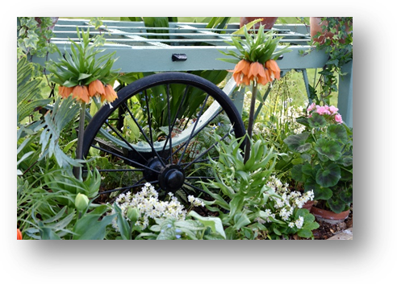
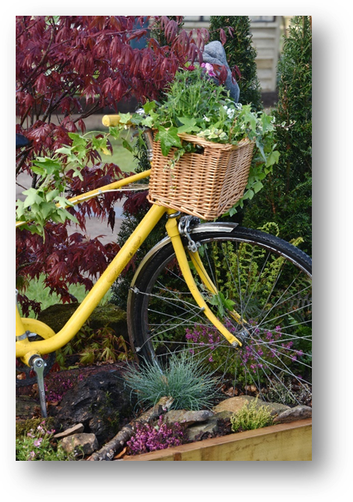

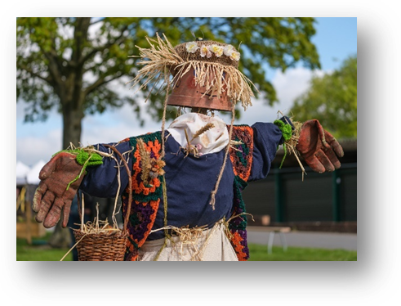

Creative Borders
Planting Competition

Thursday 23 - Sunday 26 April 2026
Great Yorkshire Showground, Harrogate

Application form

Contact details (The main point of contact)
Contact name
Company name
Address
Telephone number |  |  | Mob
Email address
Website
Twitter
Bacs details (for sponsorship and any award money)
Account number
Sort code
Sponsors details (if any)
Plot details
Raised bed size | 3.6m l x 1.2m w x 0.6m h
Creative Border title:
Describe the space (planting relevance, colour choices, planting style etc.) – continue on additional sheet if required
Image of design: please include a sketch/visual of your proposed design for use in assessing application and promotional work (this can be attached as a separate document if necessary)
Signed:

Date:

