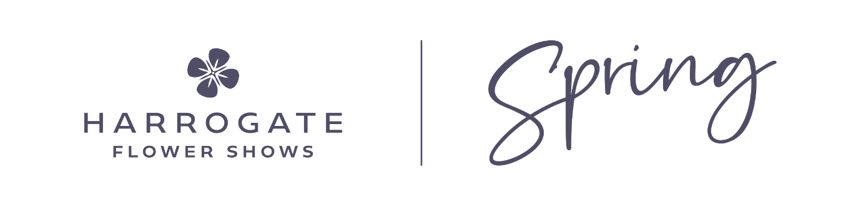

Risk Assessment

(to be signed & returned to sue@flowershow.org.uk)

Name
You are required to assess any risks or hazards to yourself, site staff and the public using the table below. If you have a Risk Assessment specifically applicable to shows, please forward it to us. Further information on completing risk assessments can be found through the following link - http://www.hse.gov.uk/risk/

Hazard/Risk  (Slipping, trip, lifting etc.) | Who is at Risk?  (Staff, public) |  | Control measures to manage the risk.  (tidy work area, correct lifting procedures etc.)
Slips and trips | Own self, public |  | - Suitable footwear to be worn  - Equipment used correctly
Spillages | Own self, public |  | - Wipe spillages up immediately  - All watering to take place outside of show hours
Manual handling | Own self, staff |  | - Manual handling in accordance with the Manual Handling Operations Regulations 1992  Trolleys used for manoeuvring of heavy items
Signed |  |  |  | Date

