

Floral Pavilion Application
Harrogate Autumn Flower Show, 18-20 September 2026
Newby Hall & Gardens

Thank you for your interest in the forthcoming Harrogate Autumn Flower Show, to be held within the grounds of our exciting autumn venue, Newby Hall & Gardens, near Ripon, between 18-20 September 2026. This event will host traditional show favourites including plant nurseries, fantastic fruit and vegetables and live theatres, alongside spectacular feature installations and activities, all forming part of a unique event for garden-lovers.

Application process
A completed application is one received by Friday 22 May 2026 with full payment and Public Liability Insurance of £5,000,000, valid between 18-20 September and a show related risk assessment. All electronic applications will receive a confirmation receipt email. Following the deadline, successful applicants will be informed via email with a link to the exhibitor area of our website. This holds essential information relating to your stand, so please ensure that all details provided are correct.

Payment & refunds
Full payment is required at the time of application and in any case, no later than the application closing date of Friday 22 May 2026. Refunds for unsuccessful applications will be made by BACS once allocation has been completed in early July 2026. Please note cancellation fees apply.

Build, breakdown and use of contractors
If using a contractor at any time, exhibitors are required to inform Harrogate Flower Shows, providing details of stand build, and copies of their risk assessment and Public Liability Insurance of £5,000,000, valid across the build, live and decant period of the event.

Venue and site information
The Floral Pavilion consists of a marquee structure, on grass, located near to the main entrance of the event and incorporating a combination of wall and island nursery stands. Sales tables may be purchased by completing the relevant section within the attached application. Plant storage will be provided to the rear of the marquee structure. For those exhibitors wishing to place orders for temporary electricity supply, this is now arranged independently to the main application, with forms issued to successful applicants separately upon allocation, in early July 2026.

Please note that black staging cloth is NOT PROVIDED as part of your display and is the responsibility of exhibitors to organise in advance.

A maximum of two exhibitor badges and one parking pass are provided per stand.

Display & products to be exhibited
Judging within the Floral Pavilion will follow traditional/scientific judging criteria, with awards and associated prize monies based upon Bronze to Premier Gold awards.

Please be aware that completion of this application does not represent a guarantee of space within the event. All applications and subsequent allocation of stands is at the discretion of Harrogate Flower Shows and although we aim to work with you as much as possible, we cannot guarantee the same stand as at any previous show. In completing this form, exhibitors are agreeing to T&C’S as set out here: https://www.flowershow.org.uk/autumn-show/take-part/rules-and-regulations

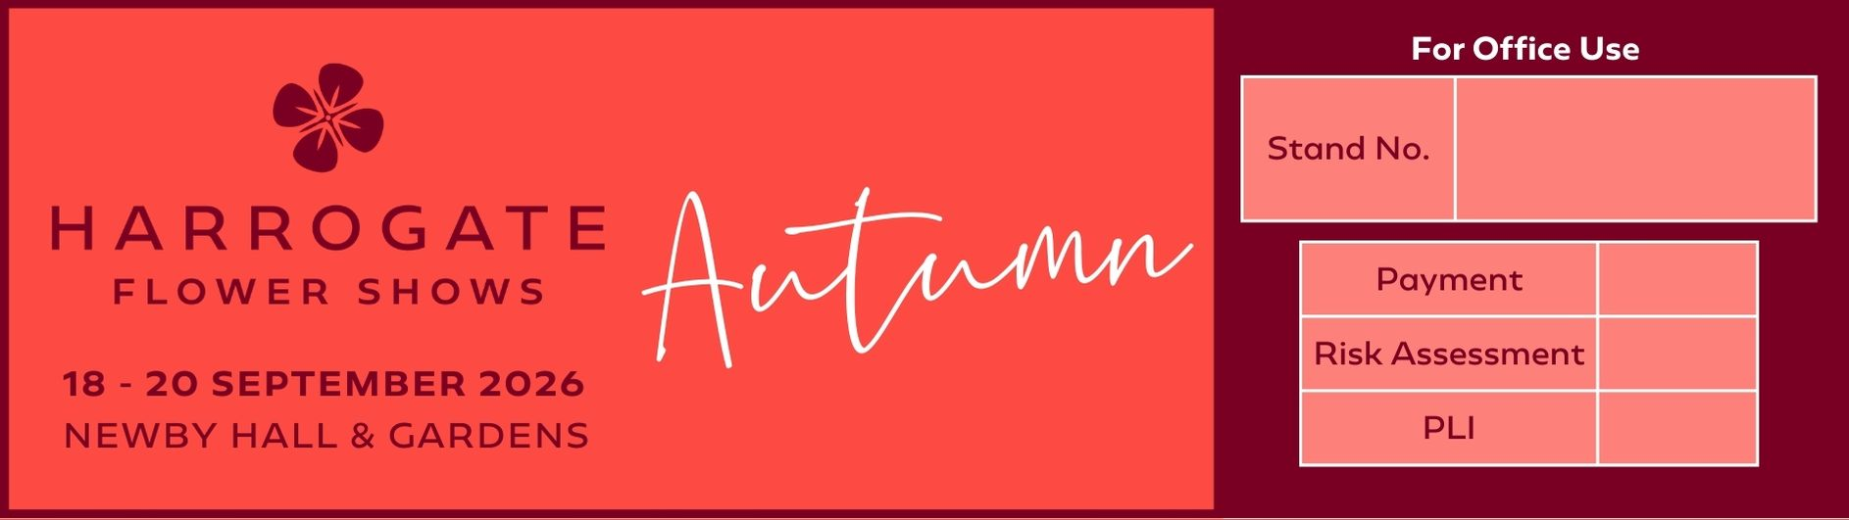

18-20 September 2026 – Newby Hall & Gardens

Floral Pavilion Application

Contact name

Trading name

Address |  |  |  | Alternative details for promotional use
Telephone number |  |  |  | Mobile
Email address

Website (for inclusion on our website)
Plant types (display & judging)
Please specify judging criteria | Traditional |  | Educational/Scientific
Plant types to be sold
Sales tables |  | Cost |  |  |  | Total cost Inc. VAT
1 x selling table, 1.8m x 0.75m |  | £120 + £24 VAT
2 x selling tables, 3.6m x 0.75m |  | £230 + £46 VAT
3 x selling tables, 5.4m x 0.75m (Island stands only) |  | £285 + £57 VAT
Total cost Inc. VAT

Do you require staging? |  |  |  |  |  |  | YES
 |  |  |  |  |  |  | NO
If no, state space only size in metres. Note, cannot exceed 6m x 2m if regular stand, or 3m x 4m if island stand.

Staging requirements (Please see attached staging sheet to select staging type, skip section if space only).
Option 1) - Island stands (answer 1 & 2)
- State height of island stand. |  |  |  |  | 30cm from floor
 |  |  |  |  | 60cm from floor
 |  |  |  |  |  | No edging |  |  | 10cm deep |  |  | 15cm deep
 | 3m | Circle
 | 3m | Square
 | 3.6m | Oval
 | 4.5m | Circle
 | 4.5m | Square
Option 2) Wall stands (answer 1, 2, 3 & 4)
- Select length of stand. |  |  |  |  |  |  |  | 3m
 |  |  |  |  |  |  |  | 4.5m
 |  |  |  |  |  |  |  | 6m
 |  |  |  |  |  |  |  | 7.5m
 |  |  |  |  |  |  |  | 9m
- Do you require a 2.4m high back rail? |  |  |  |  |  |  |  | Yes
 |  |  |  |  |  |  |  | No
- State staging type (must relate to staging offered). |  |  |  |  |  |  |  |  |  | (For example - B)
- Do you require edging? If no, leave blank. |  |  |  |  |  |  |  |  |  | Front only |  |  |  | Front & sides |  |  |  | All round
 |  |  |  |  |  |  |  | 10cm deep
 |  |  |  |  |  |  |  | 15cm deep
Do you have any other comments relating to your staging?

Any award monies or refunds will be made by BACS, please complete details below.
Bank name |  |  |  |  |  |  |  |  |  |  | Sort code
Name on account |  |  |  |  |  |  |  |  |  |  | Account code
Payment:
- Only completed application forms with full payment will be considered for space.
- All invoices will be e-mailed.
- We do not accept cheques

The following must also be provided with your application:
- Proof of Public Liability Insurance (£5,000,000) valid over event dates
- Completed Show Related Risk Assessment

BACS (preferred).  Please state trading name as BACS reference |  |  |  |  |  | Account name: Harrogate Flower Show Ltd  Account number: 02562332  Sort code: 53-50-21
Credit/debit card |  |  |  |  |  | Please telephone 01423 648211
Please use the box below for any comments.
Note:
- Please ensure that your completed application together with full payment and Public Liability Insurance £5m are received by Harrogate Flower Show no later than Friday 22 May 2026.
- All space and categorisation therein, is allocated at the discretion of the organiser.

Signed

Date

