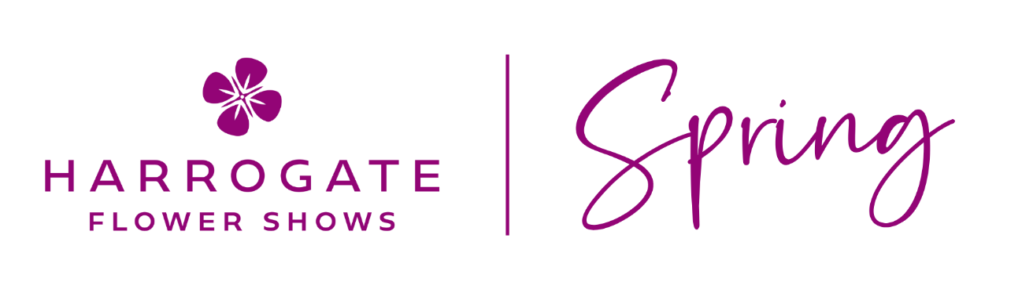

23 – 26 APRIL 2026 GREAT YORKSHIRE EVENTS CENTRE

List of Winners & Awards

Best in Show:

Melissa Morton Garden Design - APL

SHOW GARDENS

New Build Manifesto | Yorkshire Pastoral | Premier Gold
Horticap | “The things that make me different, make me.”  Winnie the Pooh | Premier Gold
Hazel and Green | Gardens That Grow With You | Silver Gilt
Hadean Landscape & Planning Ltd | Water’s Edge Retreat | Silver

ASSOCIATION OF PROFESSIONAL LANDSCAPERS SHOW GARDENS

Melissa Morton Garden Design | The Breathing Space | Best in Show
J Paxman Landscapes | Common Ground | Gold
Harrogate Garden Design | Hidden Currents | Gold

